**ASSIGNMENT 1 ON SDLC MODEL**

1. **Discuss the prototyping model. What is the effect of designing a prototype on the overall cost of the project**?

**Ans :-** Prototyping is defined as the process of developing a working replication of a product or system that has to be engineered. It offers a small scale facsimile of the end product and is used for obtaining customer feedback as described below:

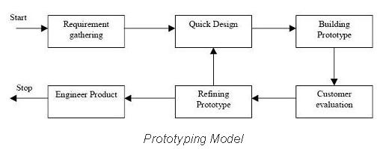

Prototype is the act of making the software applications prototypes which is basically an incomplete version of the software program that is being developed. It takes place in software development and is comparable to prototyping as known in other fields like that of manufacturing and mechanical engineering. However, it is completely different from that of the final product and stimulates only a few aspects.

Prototyping may have some initial costs of developing, but it reduces the overall budget by helping your product to be free of the errors or glitches that could have occurred if the idea was made from scratch without any prior user testing. Furthermore, prototyping also helps to understand the intrinsic flaws, shortcomings and drawbacks that can be improved during the product development process. If the prototyping process is ignored completely, it might result in the restructuring and redesigning of the entire product after spending all your resources on its development. So, the effect of designing a prototype on the overall cost of a software project is to actually reduce the additional costs of restructuring and reframing it after its full-fledged development- which might cost a fortune.

1. **Compare iterative enhancement model and evolutionary process model ?**

**Ans :-**

Iterative Enhancement Model: This model has the similar phases as the waterfall model, but with fewer restrictions. In general the phases occur in the same order as in the waterfall model but these may be conducted in several cycles. A utilizable product is released at the end of the each cycle with each release providing additional functionality.

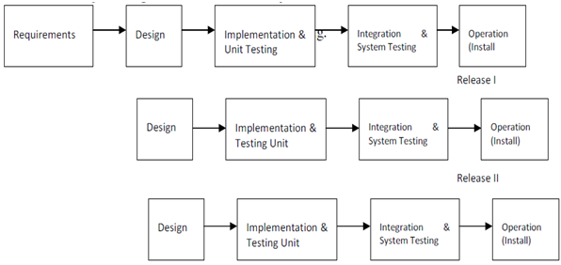

Evolutionary Development Model: Evolutionary development model bear a resemblance to iterative enhancement model. The similar phases as defined for the waterfall model occur here in a cyclical fashion. This model is different from iterative enhancement model in the sense that this doesn't require a useable product at the end of each cycle. In evolutionary development requirements are implemented by category rather than by priority.

===============================================================

1. **As we move outward along with process flow path of the spiral model, what can we say about software that is being developed or maintained ?**

**Ans :-**

As work moves outward on the spiral, the product moves forward a more complete state and the level of abstraction at which work is performed is reduced ( i.e., implementation specific work accelerates as we move further from the origin).

1. **Explain the Scrum Agile methodology ?**

**Ans :-**

Scrum is an [agile development methodology](https://www.digite.com/agile/agile-methodology/) used in the development of Software based on an iterative and incremental processes. Scrum is adaptable, fast, flexible and effective agile framework that is designed to deliver value to the customer throughout the development of the project. The primary objective of Scrum is to satisfy the customer’s need through an environment of transparency in communication, collective responsibility and continuous progress. The development starts from a general idea of ​​what needs to be built, elaborating a list of characteristics ordered by priority (product backlog) that the owner of the product wants to obtain.

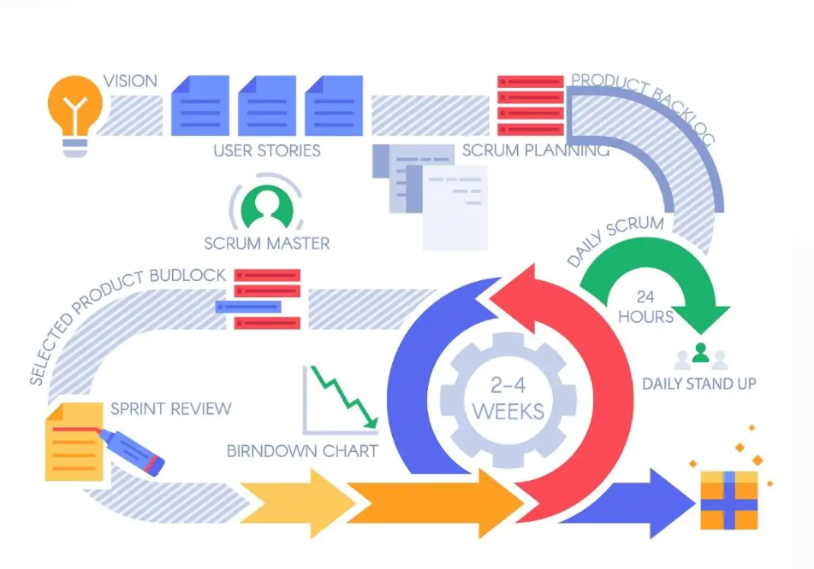

Scrum Methodology & Process

Scrum is precisely an evolution of Agile Management. Scrum methodology is based on a set of very defined practices and roles that must be involved during the software development process. It is a flexible methodology that rewards the application of the [12 agile principles](https://www.digite.com/agile/agile-methodology/#agile-principles) in a context agreed by all the team members of the product.

Scrum is executed in temporary blocks that are short and periodic, called Sprints, which usually range from 2 to 4 weeks, which is the term for feedback and reflection. Each Sprint is an entity in itself, that is, it provides a complete result, a variation of the final product that must be able to be delivered to the client with the least possible effort when requested.

The process has as a starting point, a list of objectives/ requirements that make up the project plan. It is the client of the project that prioritizes these objectives considering a balance of the value and the cost thereof, that is how the iterations and consequent deliveries are determined.

Scrum methodology is used mainly for software development, but [**other sectors**](https://www.benlinders.com/2016/agile-scrum-beyond-sw-development/) are also taking advantage of its benefits by implementing this methodology in their organizational models such as sales, marketing, & HR teams etc.

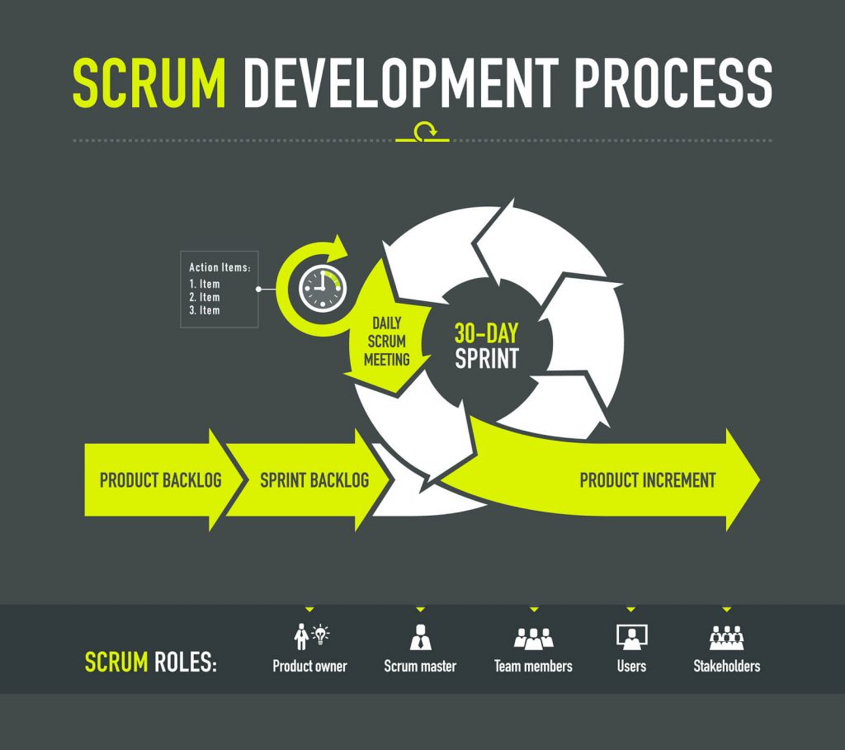

1. **Explain the utility of Kanban CFD reports ?**

**Ans :-**

A Cumulative Flow Diagram is a graphical representation of work as it flows through your Kanban system. It is a time-based plot, with the time interval in the x-axis and the number of cards in the y-axis. The graph is divided into different colored bands, with the bands representing a state or column in your Kanban board.

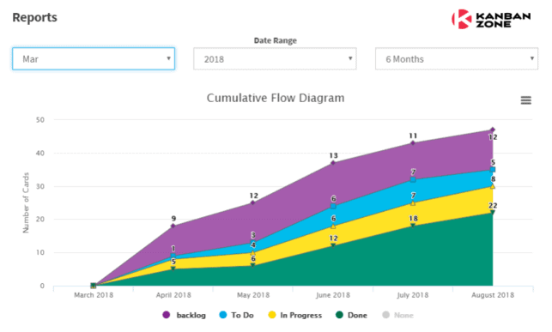

The CFD only requires 3 basic things from the process - a Backlog, an In Progress column and a Done section - using this type of division allows you to read valid and usable information from the diagram. Therefore, any team, that utilizes this kind of workflow division, can benefit from Cumulative Flow. Whether you use **Scrum**, **Kanban** or any other custom project management method, for as long as you organize it in task groups, the CFD will be of great help.